3.9 - Editors - Outliner
Outliner 1
Using the Outliner 1
Selecting and Activating 2
Context menu 3
Toggling object-level restrictions 3
Searching 4
Filtering the display 4

Outliner

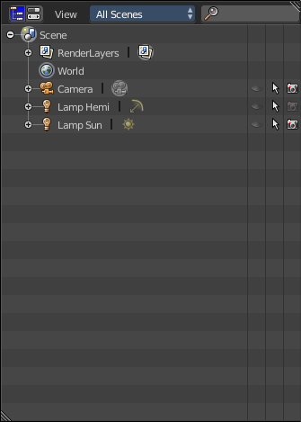
The Outliner window.
The Outliner is a list that organizes data in your scene. In the outliner, you can:
- View the data in the scene.
- Select and deselect objects in the scene.
- Hide or show an object in the scene.
- Enable or disable selection (to make an object “unselectable” in the 3D View).
- Enable or disable the rendering of an object.
- Delete objects from the scene.
- Unlink data (equivalent to pressing the X button next to the name of a data-block).
- Easily select which render layer to render.
- Easily select which render pass to render (for example, you can choose to render just the Specular pass).

Using the Outliner
Each row in the Outliner shows a data-block. You can click the plus-sign to the left of a name to expand the current data-block and see what other data-blocks it contains.
You can select data-blocks in the Outliner, but this won’t necessarily select the data-block in the scene. To select the data-block in the scene, you have to activate it.

Selecting and Activating
Single selection doesn’t require any pre-selection: just work directly with LMB (and/or RMB - contextual menu, see below) inside the name/icon area.
When you select an object in the list this way, it is selected and becomes the active object in all other 3D Views. Use this feature to find objects in your 3D View, select them in the Outliner, then zoom to them with View ‣ Show Active or NumpadPeriod.
Activating a data-block
Activate the data-block with LMB on the icon of the data-block. Activating the data-block will automatically switch to the relevant mode. For example, activating the mesh data of the cube will select the cube and enter Edit mode while activating the object data of the cube will select the cube and enter Object mode (see right).
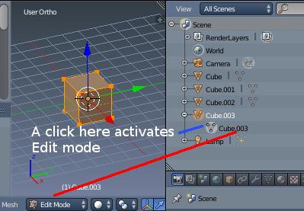
Toggling pre-selection of a data-block.
Toggle pre-selection of a group of data-blocks
Useful when you want to select/deselect a whole bunch of data-blocks. For this you must prepare the selection using, to your liking:
- RMB or LMB,
- Shift-RMB or Shift-LMB,
- RMB and drag or LMB and drag,
all outside the name/icon area. Those pre-selected have their line in a lighter color. You then can (de)select them with a RMB on the name/icon area, which brings on a context menu (see bellow).

Context menu
Right click at an item and you will see the context menu. Depending on the type of the pre-selected data-block(s), you will have a different set of options.

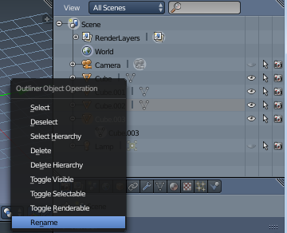

Note
Some data-block types will not have a context menu at all!

Toggling object-level restrictions
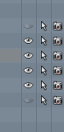
The three following options, in the right side of the Outliner window, are only available for objects:
Visibility (eye icon)
Toggles the visibility of the object in the 3D View. V will toggle this property for any objects that are selected in the Outliner.
Selectability (mouse cursor icon)
This is useful for if you have placed something in the scene and don’t want to accidentally select it when working on something else. S will toggle this property for any objects that are selected in the Outliner.
Rendering (camera icon)
This will still keep the object visible in the scene, but it will be ignored by the renderer.

Searching
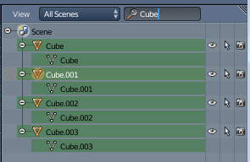
You can search the file for data-blocks by using the Search menu in the header of the Outliner
Matching data-blocks will be automatically selected.

Filtering the display
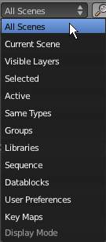
The window header has a field to let you select what the outliner should show to help you narrow the list of objects so that you can find things quickly and easily.
All Scenes
Shows everything the outliner can display (in all scenes, all layers, etc.)
Current Scene
Shows everything in the current scene.
Visible Layers
Shows everything on the visible (currently selected) layers in the current scene. Use the layer buttons to make objects on a layer visible in the 3D window.
Selected
Lists only the object(s) currently selected in the 3D window. You can select multiple objects by Shift-RMB -clicking.
Active
Lists only the active (often last selected) object.
Same Types
Lists only those objects in the current scene that are of the same types as those selected in the 3d window.
Groups
Lists only Groups and their members.
Libraries
TODO *
Sequence
TODO *
Data Blocks
TODO *
User Preferences
TODO *
Key Maps
TODO *

*Thank you Blender devs for not having a complete manual after 20 years ...

